1. Dugesia is a member of which domain?
a. Archaea
b. Bacteria
*c. Eukarya

2. Dugesia is classified into which phylum?
a. Annelida
b. Arthropoda
c. Chordata
d. Cnidaria
*e. Platyhelminthes

3. Dugesia have which type of symmetry?
*a. bilateral
b. radial

4. Dugesia exhibit cephalization.
*a. true
b. false

5. Dugesia have
a. a complete digestive system
*b. a gastrovascular cavity

6. Which animal is not a member of the same phylum as planarians?
a. liver flukes
*b. polychaetes
c. tapeworms
d. marine flatworms

7. What type of nervous system is found in Dugesia?
*a. anterior pair of ganglia with ventral nerve cords
b. cerebral ganglia, ventral nerve cords, and segmental ganglia
c. complex folded brain, spinal cord and nerves
d. nerve net

8. Is Dugesia diploblastic or triploblastic?
a. diploblastic
*b. triploblastic

9. Which type of excretory system is present in Dugesia?
a. kidneys
b. metanephridia
*c. protonephridia
d. antennal glands
e. no excretory system is present

10. On the planarian diagram below, the structure labeled “a” is the

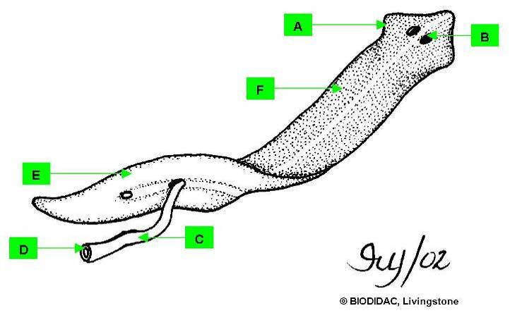

*a. auricle
b. dorsal surface
c. eyespot
d. mouth
e. pharynx
f. ventral surface

11. On the planarian diagram below, the structure labeled “b” is the

a. auricle
b. dorsal surface
*c. eyespot
d. mouth
e. pharynx
f. ventral surface

12. On the planarian diagram below, the structure labeled “c” is the

a. auricle
b. dorsal surface
c. eyespot
d. mouth
*e. pharynx
f. ventral surface

13. On the planarian diagram below, the structure labeled “d” is the

a. auricle
b. dorsal surface
c. eyespot
*d. mouth
e. pharynx
f. ventral surface

14. On the planarian diagram below, the structure labeled “e” is the

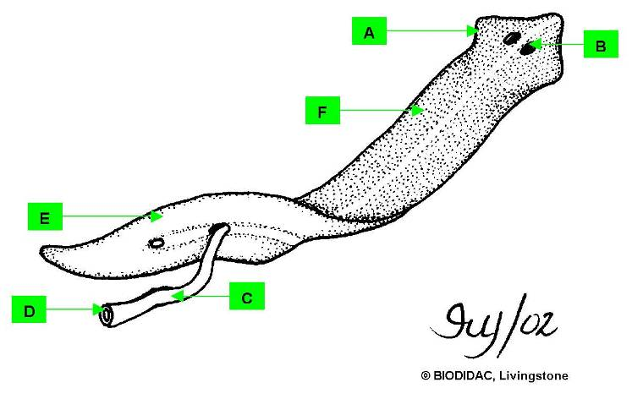
a. auricle
b. dorsal surface
c. eyespot
d. mouth
e. pharynx
*f. ventral surface

15. On the planarian diagram below, the structure labeled “f” is the

a. auricle
*b. dorsal surface
c. eyespot
d. mouth
e. pharynx
f. ventral surface

16. On the planarian cross section diagram below, the structure labeled “a” is the

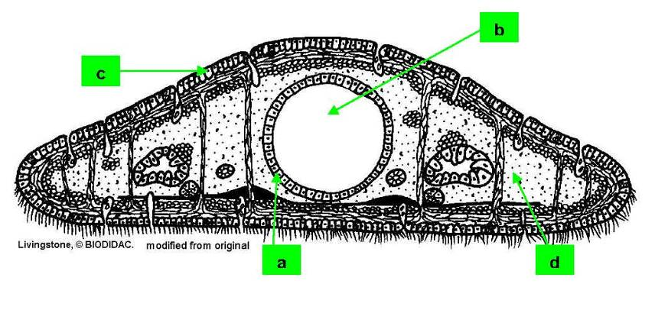

a. epidermis
*b. gastrodermis
c. gastrovascular cavity
d. mesenchyme

17. On the planarian cross section diagram below, the structure labeled “b” is the

a. epidermis
b. gastrodermis
*c. gastrovascular cavity
d. mesenchyme

18. On the planarian cross section diagram below, the structure labeled “c” is the

*a. epidermis
b. gastrodermis
c. gastrovascular cavity
d. mesenchyme

19. On the planarian cross section diagram below, the structure labeled “d” is the

a. epidermis
b. gastrodermis
c. gastrovascular cavity
*d. mesenchyme

